Multinomial Data

Business Objective – Predicting the type of program

Solution:

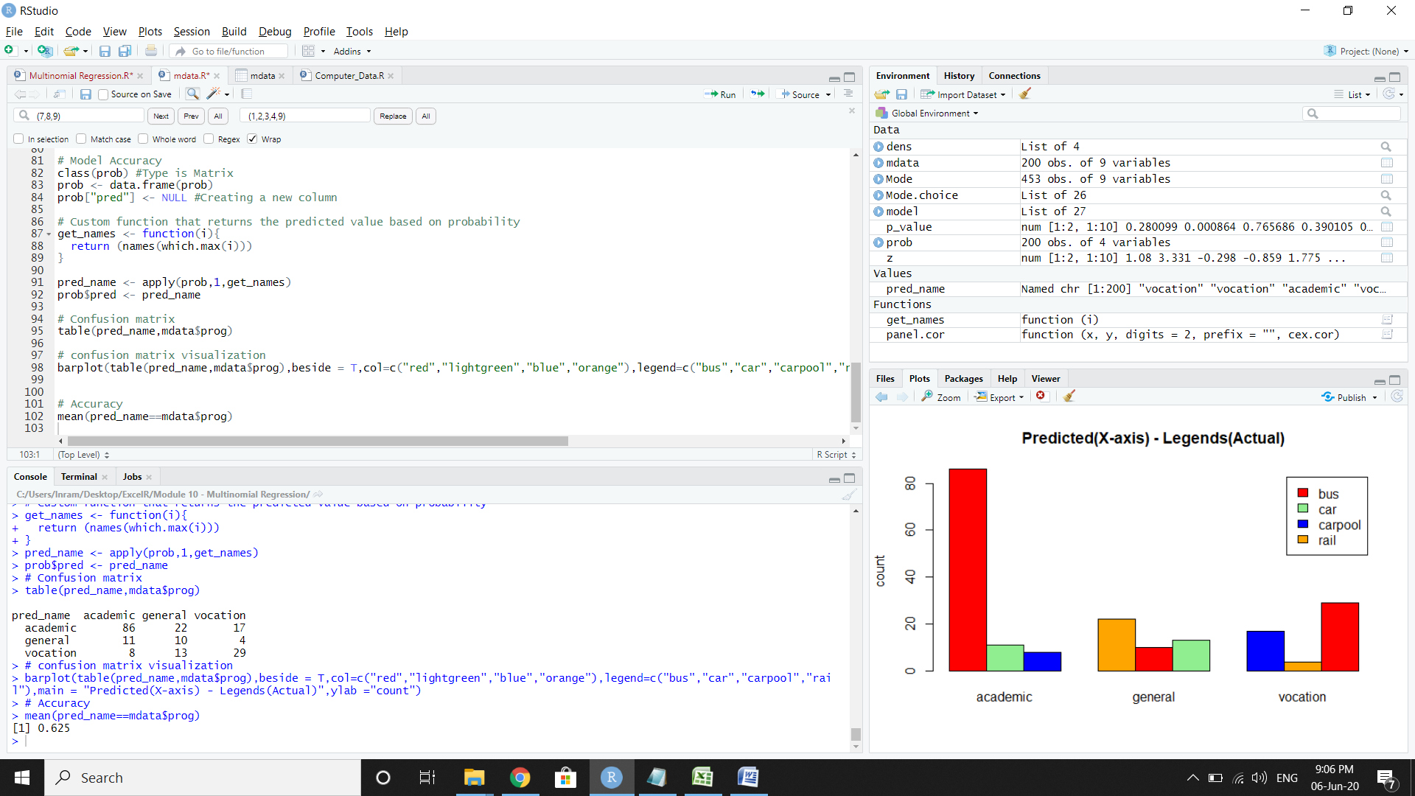

Accuracy of the model: 62.5%